Cost_change_source_cluster
- Is the source(cost_change_functions.r) reading in the functions, or the r code where the functions live? Does this code exist on github?
- Read in relevant inputs (population draws, costs and impact factors of dietary factors) and do some minor data processing.'
  - What does pop.sims do? Does cost.inputs includes “costs and impact factors of dietary factors”
- 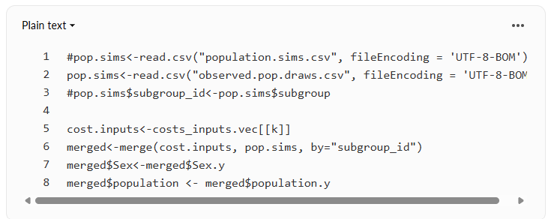 “There are 31 lists in total, corresponding so some combinaiton of 1. what we are looking at (impact (as in, impact of change), substitution impact, combined impact, population, delta (aka, change in intake), current intak eimpact, counterfactual intake impact), and 2. level of disaggregation (total, consumed, unconsumed, inedible, wasted). Hopefully, what each list corresponds to is clear from name.”
  - what are the differences between some of the categories in #1? Such as substitution impact, impact of change, and why are they all calculated?
- “traversing” in this context just means going through, right?
- what is the last part of this section: “Extract label variables and put them into their own data frames (to be merged later with the )”
- is mergedp[1,] a typo or did we miss an explanation/step of how we got here?
- also, it isn;t really clear what is happening once the for loop starts, extracting label variables, and giving inputs from mergedp[i,] their own object with own name. Can you describe the for loop section just a little more. Is if calculating the costs at the dietary factor and food source level for all subgroups? that what the “impacts” are? In this case, cost?
- when you say “for the sake of readability of code…” do you mean readability of the results?
  - within this section, what is this code doing:
- 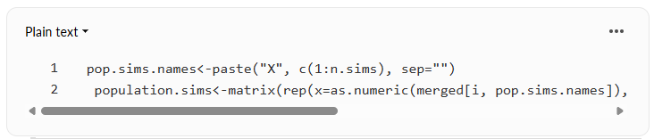 “take the above inputs and feed it into function that simulates the impact. The resulting “b” is a list of 31 matrices with simulation results that correspond to the 31 lists we made earlier.” I thought that the for loop was simulating the impact. What was the for loop doing if not calculating impacts? Whats the difference between these two sections?
- since df.aa and df.a are mentioned earlier in the code, but come back into play later on, can you add more detail as to what they are?
- for each subsection within this section “ Extract results from “b” (which itself is a list of 31 matrices) and create data frames with proper labels.”, can you provide more detail? So what is happening in all of the df.b1-b31 - what do these represent, then the same with df.c1-c31, etc. There are multiple chunks that are different. Expecially the code that starts with this section, explain what is happening here in a little more detail.
- 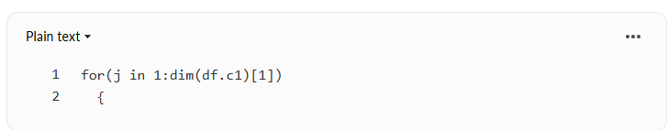 “We assign each dataframe we made to be the i-th element of their corresponding lists.” Have a sentence saying why this is done even if it seems straightforward to you. I don’t know why it’s done.
- “End the loop” okay so ALL of what was before this was the loop? There should be an indication for each section that is part of the loop so that we know it is part of the loop. so possible something like ~within loop~ at the beginning of each description that was included in the loop. I didn’t realize this was still the loop until I read “end loop”.
- “For each list, row-bind the elements of the list (corresponding to a subgroup and dietary factor) together into a data frame. Each of these dataframes has results for all dietary factors and subgroups, for one outcome (specified in name of dataframe). NAs are also repplacec with 0.” How this is written is slightly confusing - so you are row-binding elements of the list. Did each list only include one subgroup and one dietary factor? and you’re creating a dataframe based on that?
  - or did each list have rows where each subgroup was matched with each dietary factor? and now you’re making that a dataframe?
- If you are getting per capita sims now, were the above results at the population level or the subgroup level?
- Can you put in parenthesis what the summary stats are that you will be getting?”Get summary stats from simulations for all outcome of interests and save (for both total and per capita impact).”
- “The first level denotes outcome type: 1 = total summary stats, 2 = total sims, 3 = per capita summary stats, 4 = per capita sims.” I don’t see anything labeled 1-4 in the code that is below this description, should I?
- “Next, we’re going to go through a for loop and output all outcomes into their own csv files for each strata combination.” In other instances where you saved things into a csv file, there wasn’t a for loop. Why is it only done here? Does the for loop improve efficiency?

